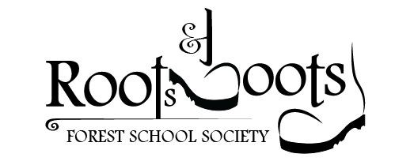

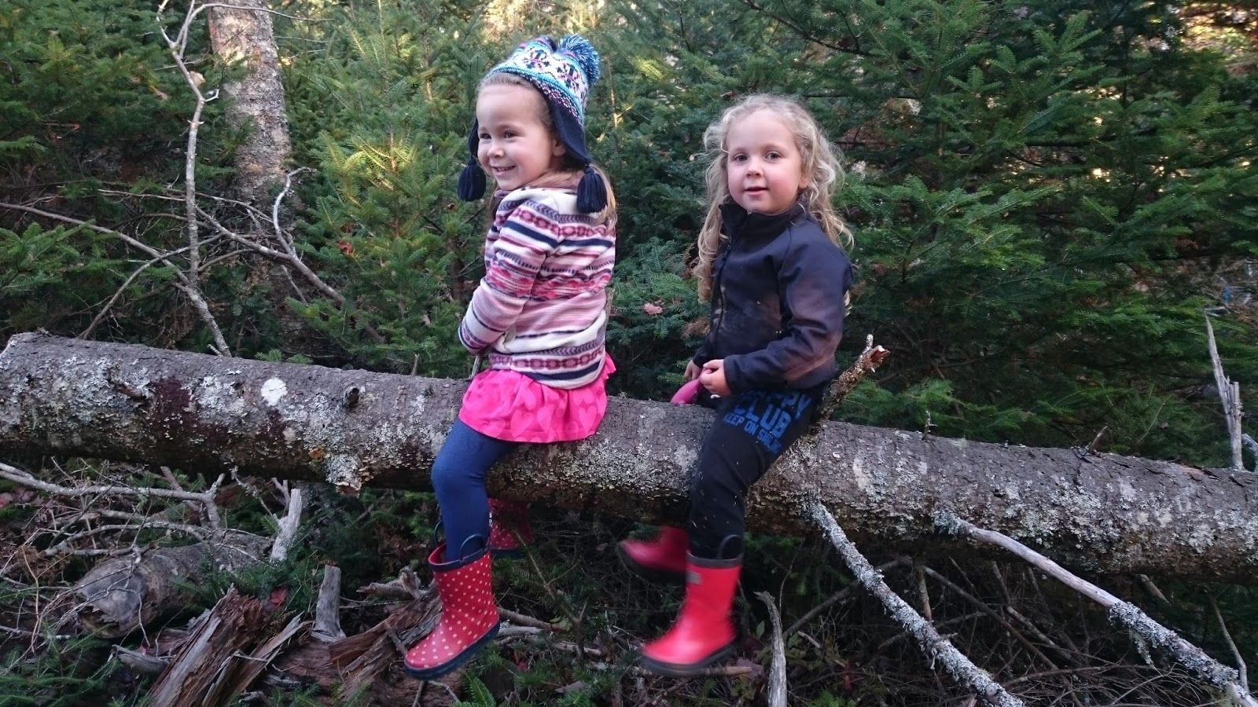

Parent Handbook
2023

Table of Contents

What is a Forest School?
Who are we?
Leader: Child Ratios What is a Typical Day? Half Day Programs
Full Day Programs
What to Wear and Pack
Parent/Caregiver Responsibilities
Washroom Use
Our Sites/How to find them
Fall River Site
Hubley Site
Registration, Payment and Refunds
Cancellations
Illness
FAQs
Emergency Plan
Medication
Behaviour Approach
Annex A- Photo Release (NOW ONLINE!)
Annex B- Liability and Consent Waiver (NOW ONLINE!)
Annex C- Contact Information
Covid Safety

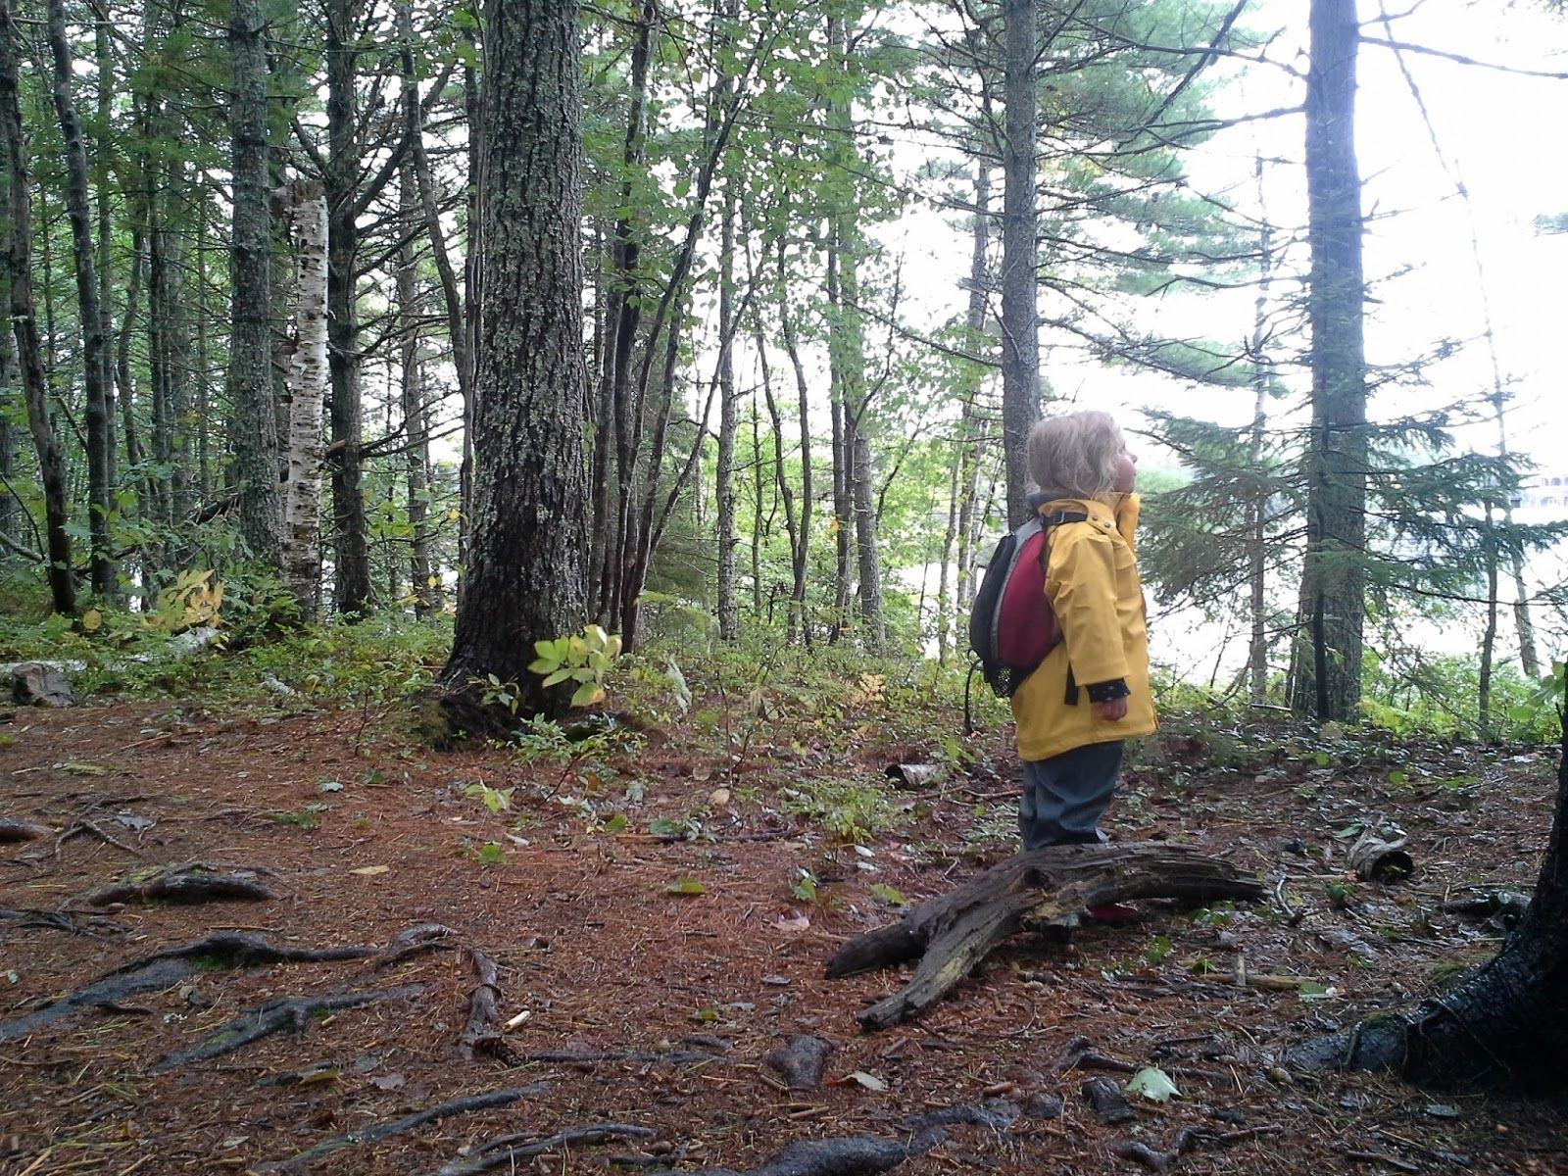

What is Forest School?
Forest School is a movement that began in the 1950s in Denmark and Sweden, and has since spread across the world. Forest School Canada defines the primary goal of Forest School as: “providing children with regular and repeated access to a natural space for child-directed, emergent and inquiry-based learning.” Throughout Canada, forest schools operate in a variety of ways. While some run for one half-day a week, others run full-time care outdoors. All Forest Schools in Canada have a few things in common: Regular and​ repeated access to the same natural space which they are able to explore in child-led, emergent and play-based learning led by knowledgeable and caring leaders.

Who Are We?
Roots and Boots Forest School was started in 2016 by Kellie Allen and Sara Wolthers. It was born from three mothers who believed in the value of immersing their children into the outdoors, and following their inquiries with the natural world. Roots and Boots is a Nova Scotia based not-for-profit society governed by a Board of Directors.

The Roots and Boots Directors are all practitioners with Forest School Canada. All groups have qualified first aid leaders on site and have a valid Criminal Record Check and Vulnerable Sector Screening which includes a Child Abuse Registry check. For more information, please visit our website at www.rootsandboots.ca.

Leader:Child Ratios
The ratio of leaders to children at Roots and Boots is 1:5 for children up to age five and 1:7 for ages six to 12 years. During our summer camp schedule, we may have students employed as leaders. They will have up-to-date certifications, as well as supervision by a trained adult.

What Is a Typical Day?

Half-day programs:
Unless otherwise indicated, half-day programs begin at 9:00 a.m. and end at 12 noon.

A usual day goes something like this:
- Arrival: parents sign children in, children get vests and whistles on
- Walk-in: (the time varies depending on the site, the children and what they spy on the way)
- Beat the Bounds: children review the play-area/exploration boundaries, pee spots and safety procedures with leaders
- Free play
- Snack time
- Guided, focused play
- Sit-spots: children find a quiet spot to sit by themselves and listen to the forest
- Story or game
- Walk out
- Pick up, parents sign children out, children return vests and whistles

Full-day programs:
Unless otherwise indicated, full day programs begin at 9:00 am and end at 4:00 pm.

Full Day programs will have two snack breaks, one lunch break, and scheduled quiet time (napping, reading, drawing, etc.) in the afternoon.

Our mornings are much like the half day and our afternoons often introduce new skills such as knot tying, whittling, fire safety and building, cookouts, hand tools or loose parts/imagination playgrounds. With older children, we often hike 1-2 km/day as we explore the woodlands together.

What to Wear and Pack

At Roots and Boots we take it outside in all kinds of weather! Neither the Lewis Lake site, nor the Fall River site have a dedicated structure so you should plan for your child to be outside for the duration of the session unless there is an emergency, lightning or extreme winds. This means the kids should have a few layers on (so they can layer up when sitting still and down when in active play) and dress for the conditions. Don’t forget, ‘conditions’ does not just mean what is falling from the sky, but also the condition of the ground (wet, snow-covered, muddy, etc.) where they will be running, crawling, sitting and sometimes laying. We recommend:

On the body:
- Waterproof pants and coat (or one-piece rainsuit)
- Sturdy, waterproof boots
- Warm socks (preferably wool in the Spring and Fall)
- Pants that allow ease of movement (no jeans please!). We suggest warm pants if the temperature is low, light pants when the temperature is high to protect skin from bugs and scratches
- A long-sleeved shirt, even in summer to protect skin from bugs, scratches and sun
- A sweater
- For low temperature days, wool mittens are good as they stay warm, several pairs
- Either a sun hat or toque (they will need one or the other!)
- Sunscreen (if you put it on at home it saves us one application, it saves us more time for exploring)

In the Bag:
- A change of clothing including shirt, underwear, pants and socks
- Spare mittens (in Spring and Fall)
- A full water bottle
- A snack (as litter-free as possible please!)
- A comfort item (if desired, keep in mind it WILL get wet and dirty)
- Bug spray (if you want to use your own)
We also ask that you label all of the belongings your child will be wearing or bringing as kids do not remember what is theirs!

Parent/Caregiver Responsibilities
It is the parent/caregiver’s responsibility to:
- make sure your child is registered and any forms are up-to-date and accurate.
- ensure your child is dressed for the session in weather-relative clothing, as well​ as prepared with back-up clothes on wet/damp days and changing weather conditions.
- provide staff with any additional information that could help us best meet your child’s needs (e.g: allergies, illness, or emotional concerns).
- let us know if your child needs assistance with washroom use.
- ensure your child has a bag with their back-up clothes, snacks, water, bug spray/sunscreen, and comfort item (if so desired).
- drop-off your child 10-15 minutes before the start of the session and pick-up no more than 15 minutes after.
- encourage your child to be brave, adventurous and have fun!
- notify us before the start of the session if your child will be absent for the day.
- notify Roots and Boots of any changes to contact information or pick-up permissions.

Washroom Use
We encourage children to use the washroom before the start of the session, as we do not have washroom facilities at all sites. There are outhouses available at Jerry Lawrence Park. Children will be expected to use the washroom outdoors. We will have regular washroom breaks. Of course, if your child needs to go in between washroom breaks they will be accompanied to the designated washroom location. Water, soap and sanitizer will be available for children to clean their hands with. If you think your child may have any issues with this, please discuss with them prior to the session.

Our Sites/How to Find Us
Fall River Site:
Our Fall River site is located at 5​ Miller Lane, Fall River, NS. Drop off and pick up will occur in the parking lot of The Open Gate.

The Fall River site is available for our use through the generosity of the Fall River Chapel. The site is approximately 14 acres of (mostly) sloping land. There are several streams that run through to Lake Thomas. The trees are a mix of hard and softwood, including some stunning, large old Maples near the top of the hill.

Lewis Lake Site:

Our Lewis Lake site is located in Jerry Lawrence Provincial Park, 4775 St Margaret’s​Bay Rd, Upper Tantallon, NS. The site is mostly flat and has many gravel trails as well as​other, more rustic trails. The site also has access to Round Lake and Lewis Lake. Drop-off and pick-up are at designated A, B or C areas around the park.

Registration, Payment and Refunds
Registration for 2023 is all online via our website! Registration will be based on a first-come basis. In some cases, registration for three-year-olds may be limited. When required, a wait-list will be created for each site.

Payment can be made online by credit card once registration is filled out. Cash, cheque or through an Electronic Money Transfer (EMT) is also available. If paying by EMT, funds can be transferred to kellie@allen.net​ If paying by cheque, please make it payable to “Roots and Boots Forest School Society”. Cash, cheque and emt payments can be made in two installments, the first is due two week prior to the first session and the second is due upon arrival at the first session. (for example, if the Spring program begins May 5th at 9:00 am, payment of half the fee is due April 21st and the other half is due on May 5th prior to start of the first session). Two weeks before a program start date, any child that no payment has been received for will be moved to the waitlist and their spot offered to another.

Any cancellation received more than two weeks before the start of a program will mean a full refund of payments made (less the admin deposit). Cancellations received less than two weeks before will not be refunded if we are unable to fill the spot.

If your child will miss a day at Forest School due to illness, vacation, etc. please let the site​ coordinator know by phone/text message before the beginning of the session​ so that we are not waiting for them. Refunds will not be given for days missed due to child illness,​family vacation, etc.

Cancellations
There aren’t many reasons to cancel Forest School, but here are some instances you might expect a day to be cancelled:

- High winds or winds in the “tropical storm” range of 61 km/h or more (either sustained or gusting)
- Dangerous road conditions such as ice or freezing rain
- Threat of Thunder/Lightning
- Forest fire

If a day is cancelled for any reason, you can expect to find out via our Facebook page or through a text message on your phone at least two hours before the start of the day. If in doubt, just give your site coordinator a call. No refunds will be given for days cancelled​due to weather or other emergency. We do our best to make up session at the end if necessary but this is not always possible.

If dangerous weather develops while Roots and Boots is in session, educators will contact parents as soon as possible for half-day programs and by 11:00am for full-day programs to announce an early dismissal and will remain with the children until all participants are picked up.

Illness
Should your child become ill during the day, parents will be notified and asked to pick up their child immediately. All other parents will be notified of the possibility of a communicable disease and what symptoms to look for.

If your child is sick with a contagious or transmittable illness (covid-19, the flu, chickenpox, fever, diarrhea, vomiting, infection, persistent coughing, swollen glands, unidentified rash/aches, lice, pink eye etc.) or is on an antibiotic, they must be kept home, respecting the public health guidelines.

Do not send your child if he/she is sick or has been sick in the past 24 hours. Please complete the covid checklist prior to each session.

FAQs:

- What about the bathroom?

At Forest School, we do it naturally. We expect that all children at Forest School are no longer wearing diapers. We plan a “nature call” just before snack time when children are taken to the designated area and helped to make it happen. Hand washing happens right after. Children are given lots of support if needed as layers of clothing can be tricky to take off and on. At Lewis Lake, we use the outhouses located in the provincial park and in Fall River we use a “luggable loo” camping-style toilet with privacy tarps.

- What should I pack for a snack and lunch?

The most important consideration at snack and lunch time is to pack something your child will eat. It’s better to send some cookies and cheese they will devour than a bag of carrots that won’t get touched. At Forest School we use a lot of energy and they need to replenish this energy. Pack a little more than your child will typically eat because they get hungry very quickly and frequently. Please be considerate of others and the environment and try to choose nut-free and low litter items if possible. Roots and Boots does not guarantee an allergen-free environment. The more independent your child can be while eating the better so please keep that in mind when choosing containers, etc. Also important is a water​bottle full of water.

Half day - Provide 1 snack
Full day - Provide 2 snacks and 1 lunch

- What is your approach to tick prevention?

Parents are encouraged to always dress children in long pants (this also prevents scratches) and sleeves. Tucking pants into socks can also help prevent ticks. Each site has a natural, essential oil based, tick repellent on site that we can periodically spray on your child with your permission. We also strongly encourage parents to check children over for ticks as soon as they get home. Tick checks will not be done at Forest School.

4.. What are some examples of the activities my child will be doing?

The possibilities are endless! Examples include:
  - Shelter building
  - Land art
  - Exploration of the senses
  - Knots & rope skills
  - Identifying animal tracks
  - Identifying plants and animals
  - Creating fairy houses
  - Leaf & flower pressings
  - Scavenger hunts & other games
  - Running, jumping, splashing, climbing, rolling, balancing…
Each session provides natural opportunities for literacy and mathematics through storytelling, song, rhyme, reading, drama, counting, sorting, classifying and predicting.

- Why is play in nature so important?

A growing body of research has documented the value of unstructured play in natural settings. In our busy society, children are becoming less and less able to engage in full-body outdoor play. The result is children in Canada are suffering from anxiety, depression, and other mental health issues at unprecedented rates. Children need to play to process the world around them and for the joy it gives them. The forest provides an ideal environment for many reasons. One is that there are many different surfaces and structures for children to physically explore. The beauty of nature has a calming effect on children and adults, and cognitive functioning is improved by spending time in nature. Recent research indicates that the aerosols produced by trees and plants have a positive effect on how the human brain functions. Playing in nature is fun and good for your health!

5. I'd like to read more about the Forest School philosophy. Can you point me in the right​direction?

We recommend Forest and Nature School in Canada: A Head, Heart & Hands Approach to Outdoor Learning​, published by Forest School Canad​a ​ as a more in depth resource. Also the book Last Child in the Woods​ (2006) by Richard Louv, outlines the benefits of being in nature for children.

Emergency Plan
Lost Child:​
With a low child/adult ratio, high visibility vests, and frequent headcounts, the event of a child being lost is minimal. However, should a child become lost, the following procedure will be followed:

- Remaining children will be gathered in a safe location.
- Lost child will be identified. Teachers will blow their whistle, after instructing remaining children to keep their whistles quiet.
- One teacher will remain with the children while the other teacher searches for the lost child while blowing their whistle and listening for a response.
- If child is not found within 10 minutes, 911 will be called, as well as the child’s parents.

At the beginning of each session, children will be instructed to blow their whistles in response to the teacher blowing their whistle. Each child will have a whistle attached to their safety vest.

Minor injury:​

At Roots and Boots Forest School we are trained in First aid. Should your child become injured, we will provide first aid for your child and fill out an accident form for you to sign. Minor bumps and scratches are inevitable, but we make every effort to keep the children safe through supervision and risk management.

Serious injury:​

While we conduct risk evaluations and assessments of all of our activities and environments, accidents can happen. If your child becomes injured in a way that requires attention from a medical professional the following procedure will be followed:

- One teacher will administer first aid and contact the child’s parents.
- If the child requires immediate medical care 911 will be called first, then the child’s parents.

Medical Emergencies:

If an emergency injury or illness occurs, you will be contacted as soon as possible. Parents are responsible for all costs involved in emergency medical treatment, including emergency transportation if required. Roots and Boots will not be held liable for any sickness/injury of either parent/guardian or child while at these sites.

Medication
Medication, ointments etc. can be given to your child if needed. Parents are required to fill out the proper forms online at registration and to supply all medication in their original containers with the measuring tool if required. These must be labeled with the child’s name.

Behaviour Approach
Our philosophy is that discipline is about teaching children. At Roots and Boots, the expectations of behaviour (boundaries, respect, kindness, etc.) are reviewed at each session. Once a child understands the expectations but is not meeting them, the following developmentally appropriate guidance techniques will be used:

- Redirection (most of the time)
- Teaching an appropriate alternative behaviour
- Removal of privilege (if the child repeatedly doesn’t respond to redirection)
- Time-away from the group (only for children who are able to understand the reasoning behind the time away)
- Parent consult – when a child’s behavior is continually upsetting or dangerous to themselves, the staff or the other children, a conference will be called with the parents. Roots and Boots reserves the right to remove any participant from the program without a refund. We always endeavour to promote an environment of mutual respect.

Annex A - Photo Consent

Photo Consent (online in 2023, not necessary to print and submit)

Roots and Boots Forest School may wish to take photographs or videos of the children while participating in the program for the purposes of documenting the children’s activities while participating in Roots and Boots Forest School. Other times, the photos may be used in promotional materials. Please indicate immediately below as to whether you consent or do not consent to Roots and Boots Forest School taking such photographs and/or videos of the child and using the photographs and videos in its promotional materials.

PLEASE CHECK ONE OF THE BOXES BELOW:

❏ Yes, I consent to Roots and Boots Forest School taking photographs and videos of my child and using such photographs and videos in its promotional materials.

❏ No, I do not consent to Roots and Boots Forest School taking photographs and videos of my child and using such photographs and videos in its promotional materials.
*Please remind the group leaders that you do not want any photos taken

❏ Yes, I consent to Roots and Boots taking photographs for documentation and educational purposes only.

❏ I do not want my child’s photograph taken for any reason.

Parent/Guardian signature: __________________________________________ Date: ____________

Child’s name: ____________________________________
Annex B- Waiver

Parental Consent and Release of Liability (online in 2023!)

This agreement must be completed in full, signed, and dated before the participant may participate in any programs offered by the Roots and Boots Forest School Society​ ​.

Name of Program: ______________________________________________

Dates of Program: ______________________________________________

Name of Child: _________________________________________________

During this program, participants will participate in outdoor activities, hiking and field observations. They will have one supervising adult for every five children attending the program for participants under five years of age and one supervising adult for every seven children five years of age and older. Participants are required to supply their own food, water, sun protection, and clothing.

This program is an exceptional recreational and learning opportunity, but is not without certain risks, dangers, hazards, and liabilities to participants. These include, but are not ​ limited to:​

- cuts, scrapes and bruises;
- strained or sprained wrists, ankles, knees or elbows;
- broken bones;
- concussion; and
- other serious injury including death.

Parents/Guardians of minors taking part in the program are required to accept these and other risks as a condition of their Minor’s participation in this venture. Parents/Guardians will be required to sign the Parental​ Consent and Release of Liability below, which would release Roots and Boots Forest School Society, and their representatives from any future claims which might arise as a result of program participation.

IN CONSIDERATION OF the Minor named below (the “Minor”) being permitted to participate in
Roots and Boots recreational activities (the “Activities”), I, _____________________________ (please print) the undersigned parent or legal guardian of the Minor, on behalf of myself, my heirs, executors, administrators and assigns, hereby:
- Acknowledge that certain risks of injury are inherent to participation in Roots and Boots Forest School and understand that serious injury, and even death, is possible in such participation and may result from the Minor’s actions, the actions or interactions of others, or a combination of both.
- Give permission for the Minor to participate in the Activities, and assume all liability for risk of or harm to the Minor associated with such participation.
- Release and forever discharge and hold harmless Roots and Boots Forest School Society (the “Organizers”) and their respective staff, employees, agents, representatives, successors and assigns (collectively the “Releases”) of and from any and all liability, claims, demands, damages, costs, expenses, legal costs, actions, and causes of action (collectively, the “Claims”) in respect of death, injury, loss or damage to the Minor, arising or to arise by reason of, and/or during, the Minor’s participation in the Activities.
- Consent to any Releasee administering, or consenting to the administration of, such emergency medical care to the Minor as such person deems appropriate in the circumstances; including transportation to a medical facility by ambulance, as deemed necessary, at my expense.
- Understand and acknowledge that the Organizers does not carry or maintain medical or disability insurance coverage for the Minor, and therefore agree to assume responsibility for insurance coverage for the Minor.
I HEREBY ACKNOWLEDGE THAT I HAVE READ AND UNDERSTAND THIS DOCUMENT AND THAT IT CONTAINS A RELEASE OF LIABILITY.

Name of child

Name of parent/guardian Signature Date

Name of parent/guardian Signature Date

Annex C- Contact Information

Website: www.rootsandboots.c​ a

Facebook page: https://www.facebook.com/rootsandbootsforestschool​ /

Instagram @rootsandboots

Staff

Name | Position | Email | Phone
Kellie Allen | Lewis Lake Site Coordinator | kellie@allen.net | (902) 489-2757

